Tapir Grocer

**For this project I am using Node JS as the frontend and backend.**

# Database

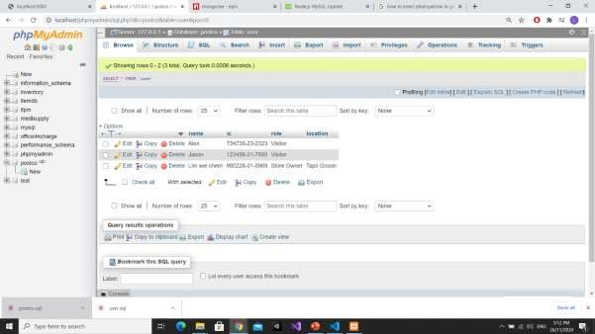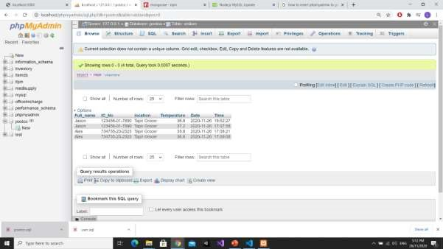

Created 2 tables (user, visitors) in database. User table is for those who are first time user and they can choose whether they are a store owner or a visitor. Visitors table is for those who successfully checked into Tapir Grocer.

# Login Page

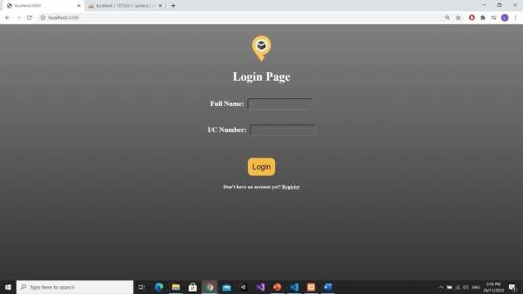

User can choose to either register for a new account or login to existing account. The login is role-based which means those that logged in as visitors will be directed to the index page of visitor and same goes for store owners.

# Register Page

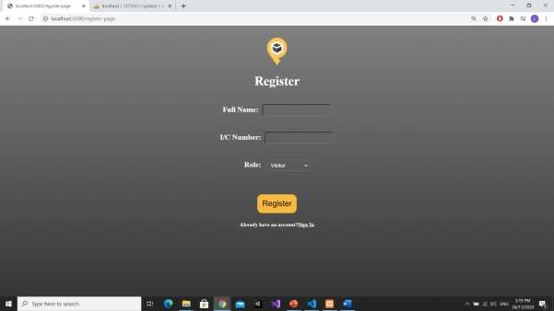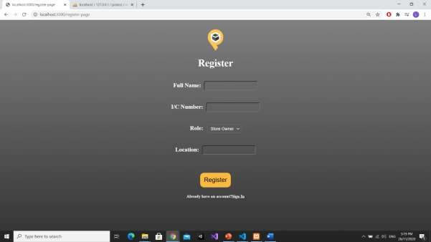

The register page allows first-time user to register their details including full name, ic, role and location(if store owner).

# Store Owner Index Page

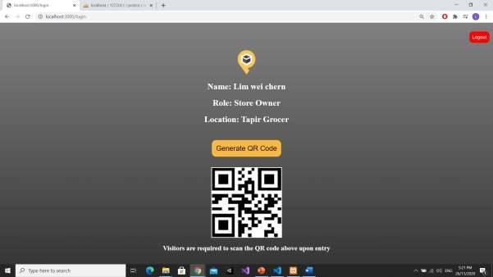

In this page, the details of the store owner will be displayed and they can click to generate a QR code for visitors to scan. Of course, The QR code is not applicable as it is just an framework of my idea.

Besides, the store owner can choose to logout of the account by clicking the logout button on the top right.

# Visitors Index Page

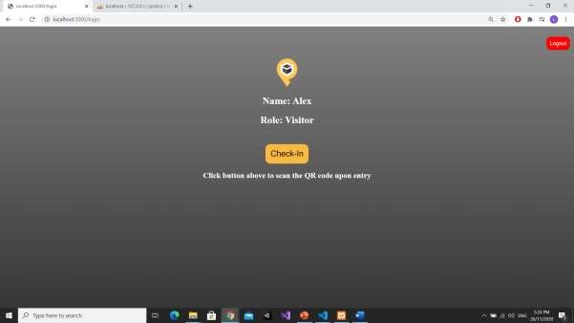

The visitor index page includes the basic details of the user and a check in button for user to direct user to next page to scan the generated QR code.

# Visitors QR-scanner page

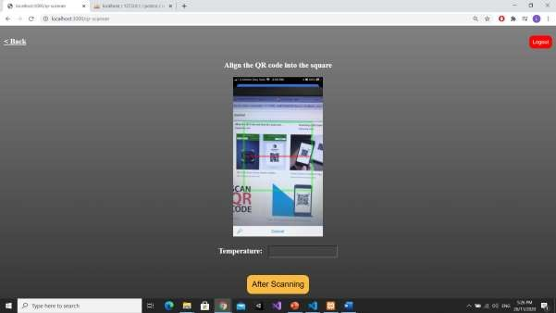

In this page, the web app will open the camera of the user and the visitor is required to scan the QR code generated by the store owner earlier. Again, the camera is not workable as it is just a representation of my idea. Also, they are also required to enter their temperature before proceeding. Besides, the visitor can elect to go back to the main page on the top left.

# Visitor Details Page

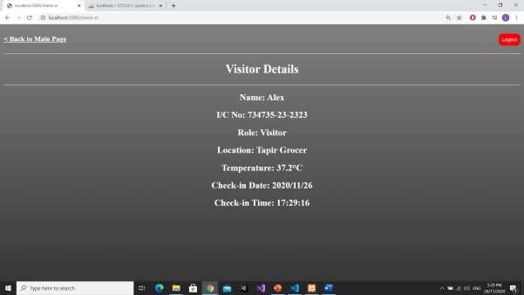

After successful scanning, the details of the visitor including their name, ic, role, location, temperature, check-in date, check-in time will pop out in this page.